Patients with Parkinson's in gait:

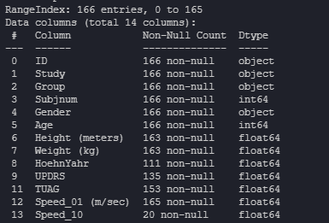
- From this we can see the specific parameters that have null values which will help us determine which parameters can be viable to use when figuring out a correlation. Speed_10 would not be a viable identifier but the rest has enough data to predict some correlations.

